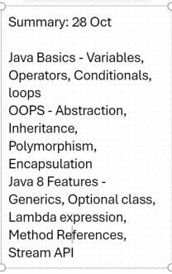

Collections

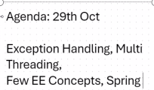

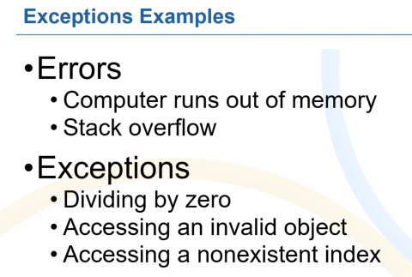

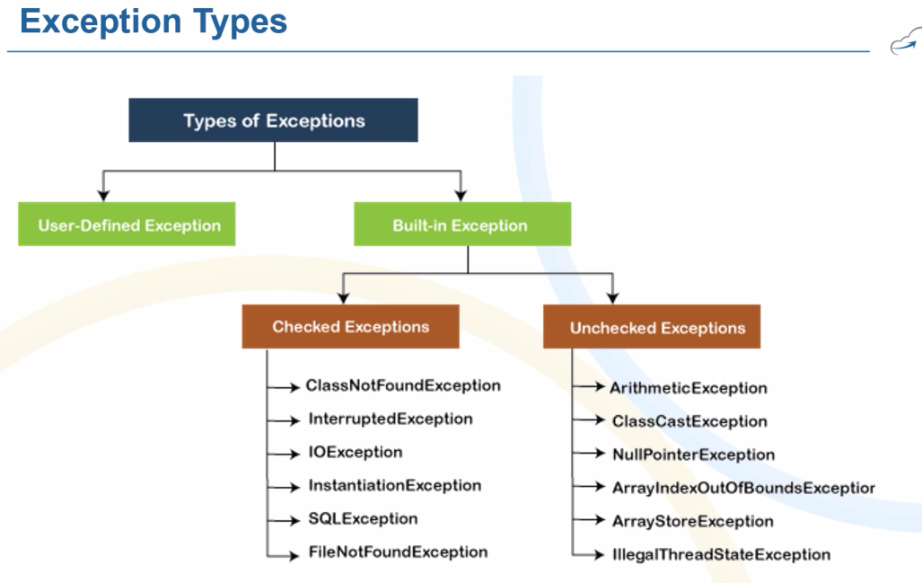

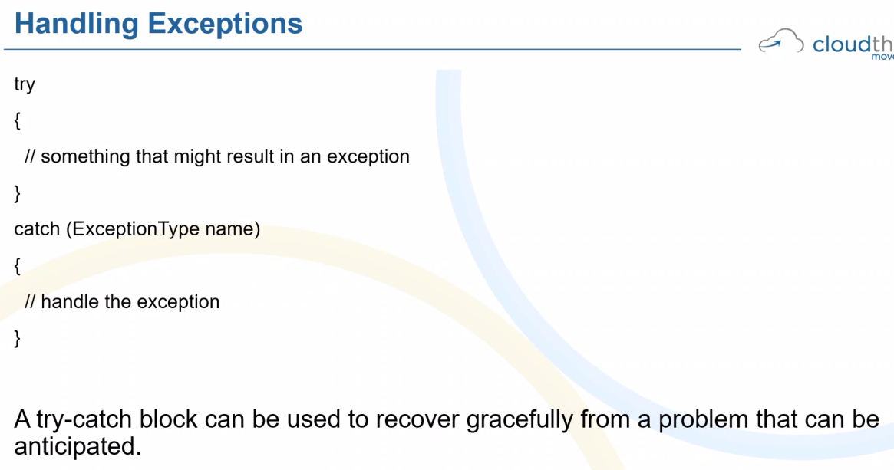

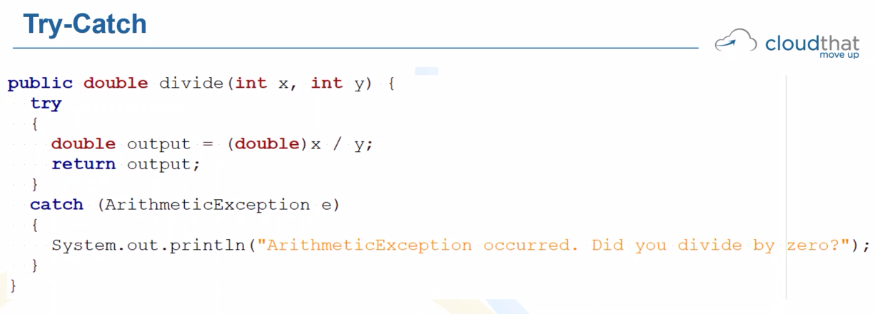

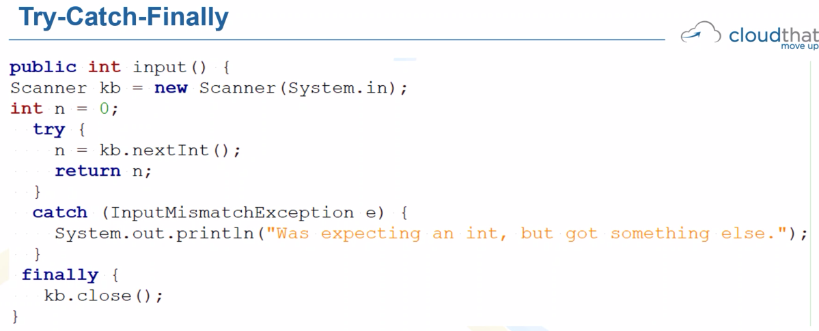

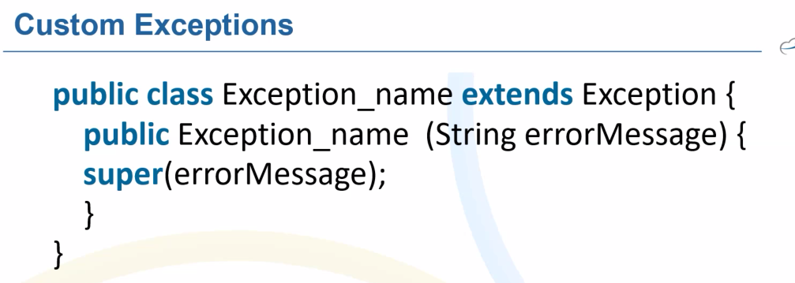

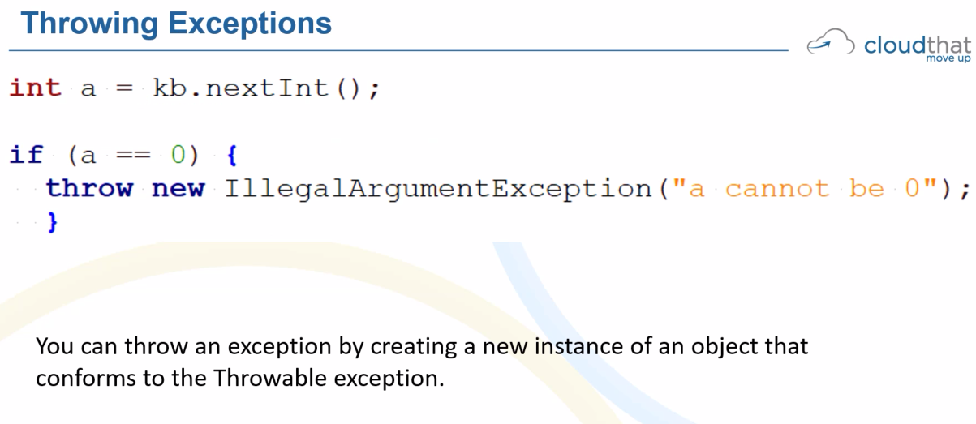

Exception handling

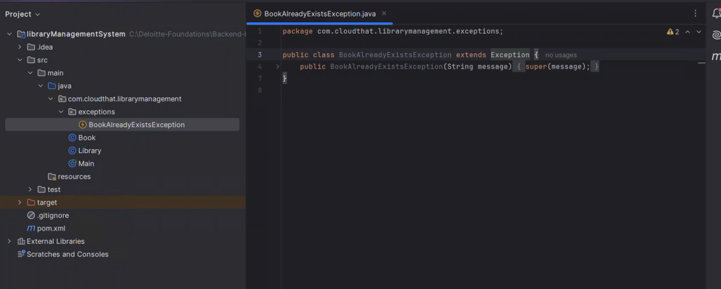

Library class file

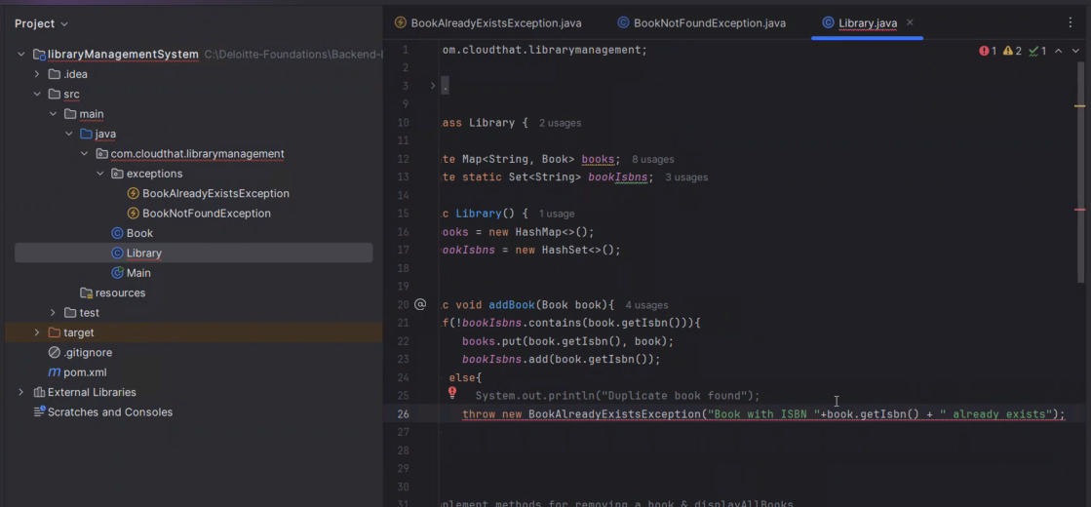

Bookalreadyexitsexception file

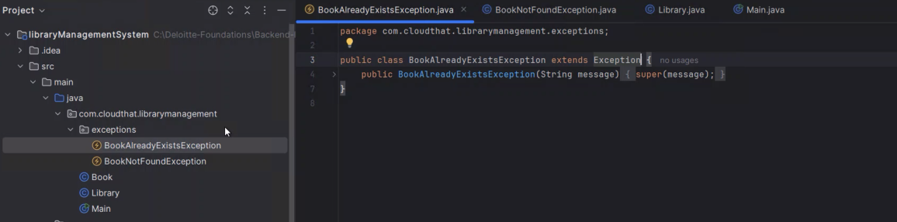

BooKnotfoundexception file

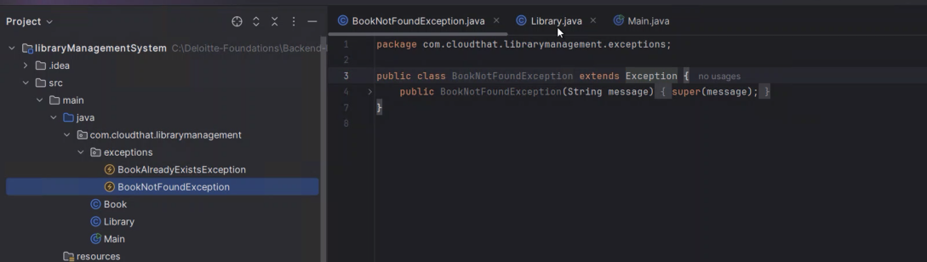

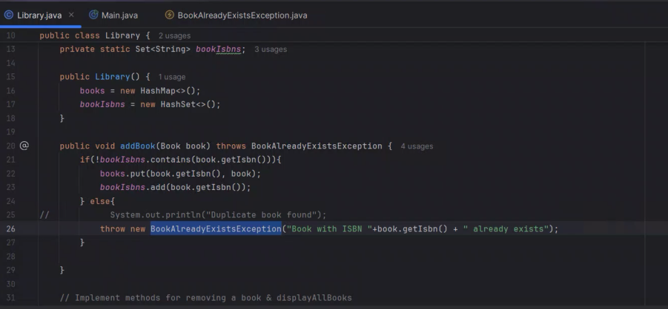

<https://github.com/Deloitte-vishwas/Deloitte-Foundations.git>

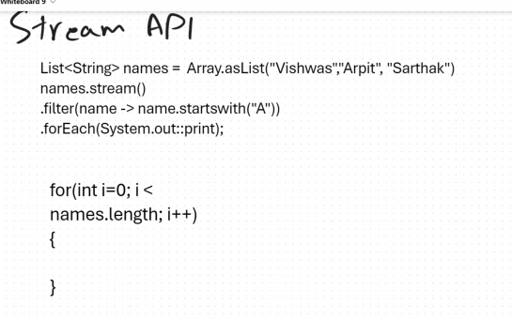

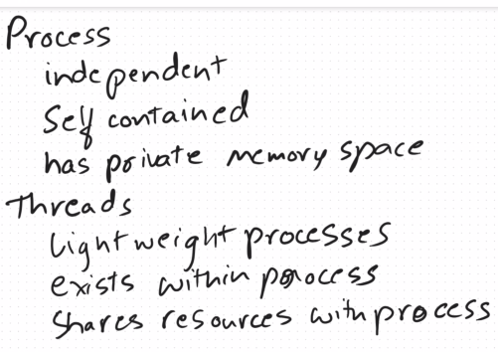

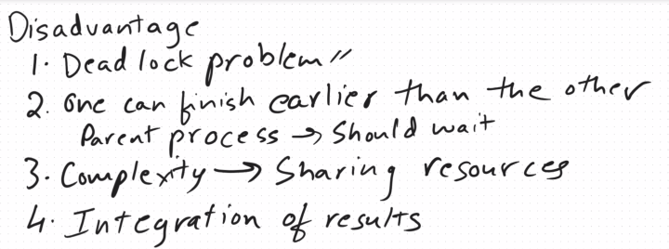

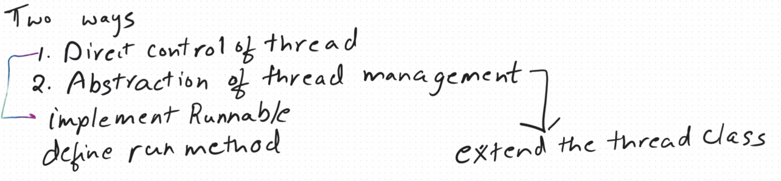

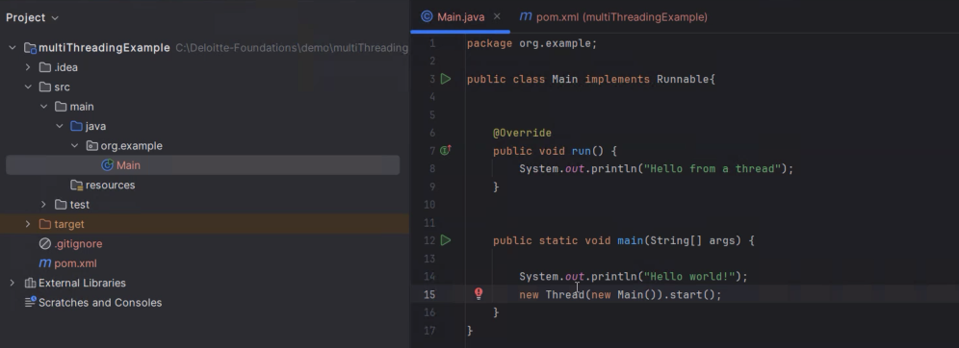

Multi-Threading -> need to learn.

<https://docs.oracle.com/javase/tutorial/essential/concurrency/procthread.html>

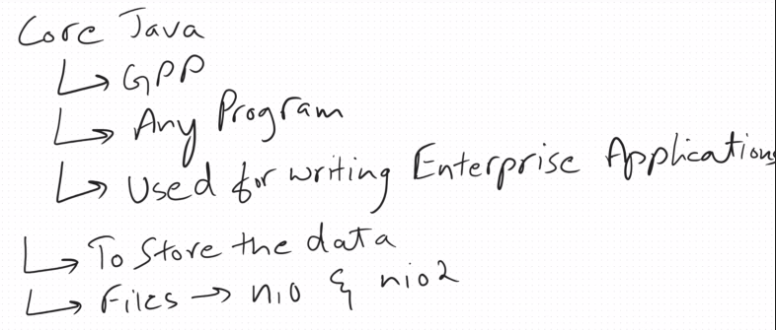

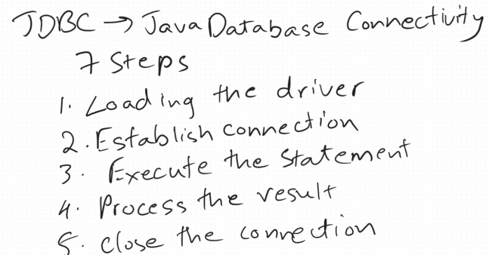

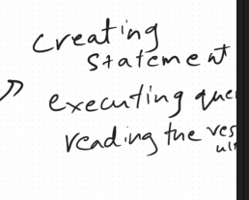

CGI Scripting

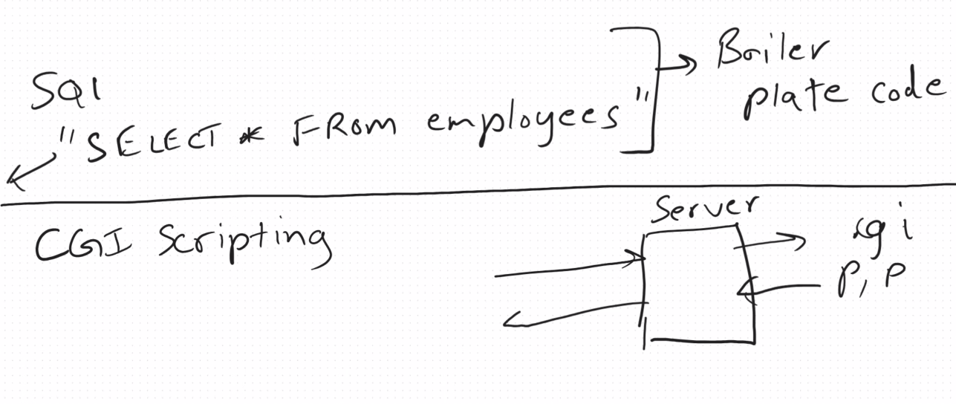

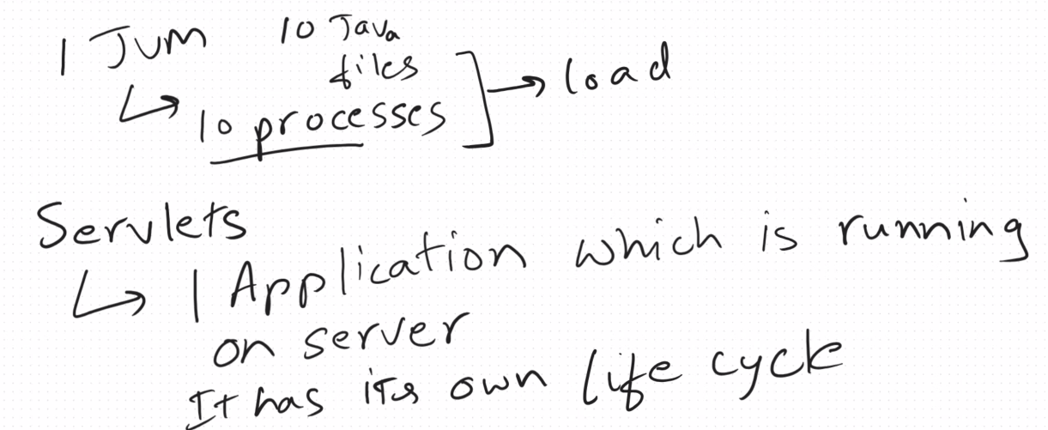

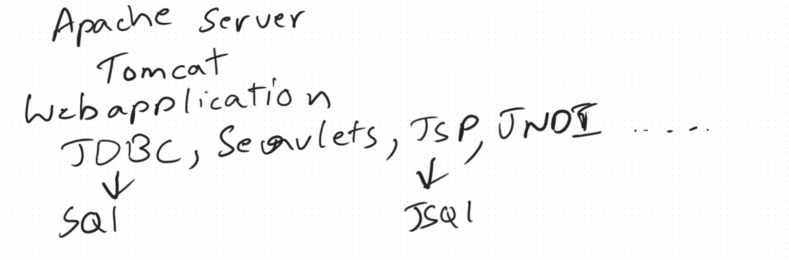

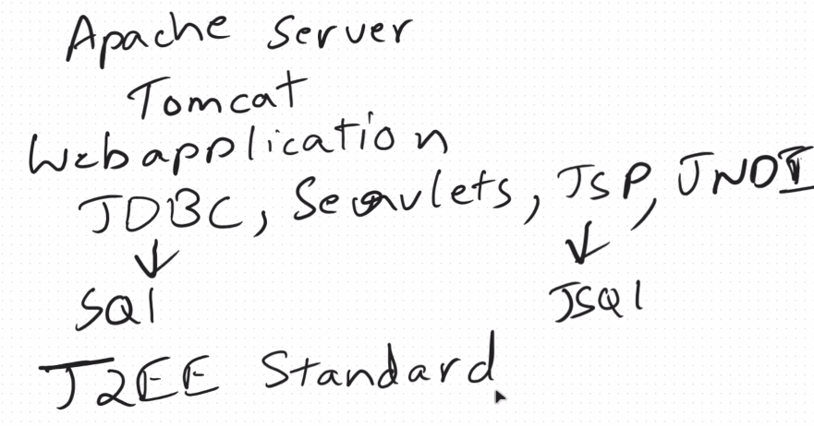

**SPRING**

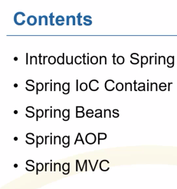

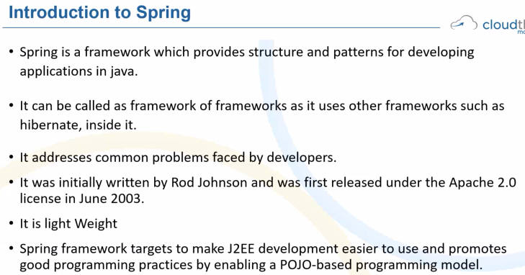

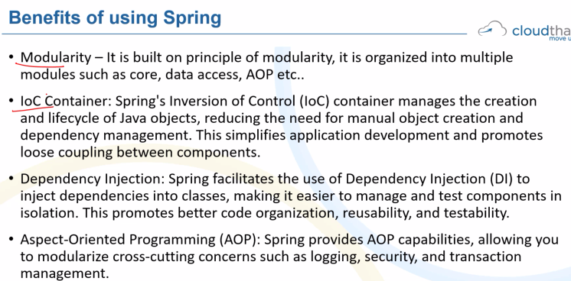

**IoC – Inversion of Control**

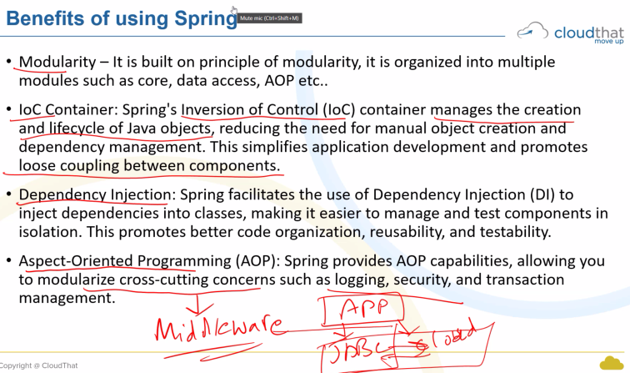

<https://spring.io/projects>

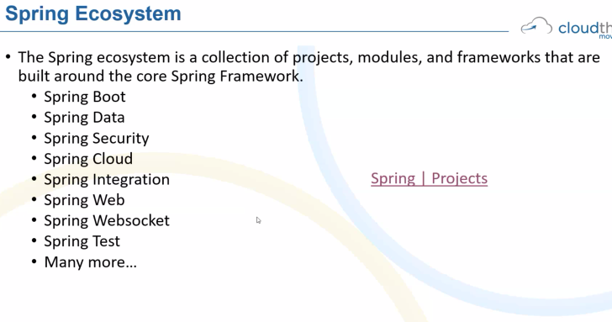

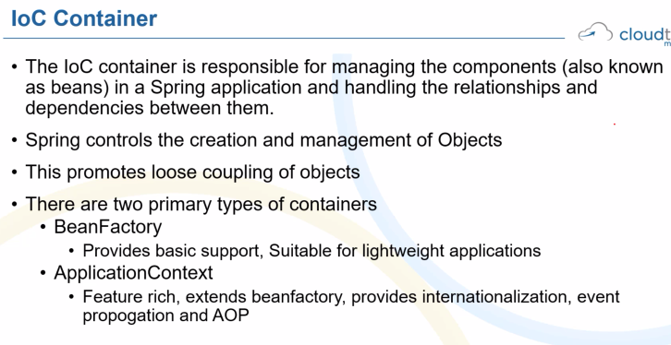

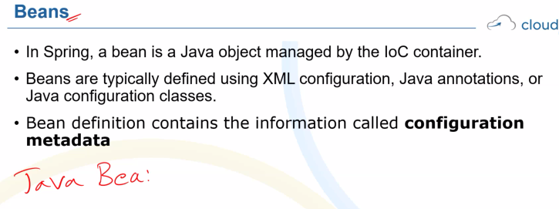

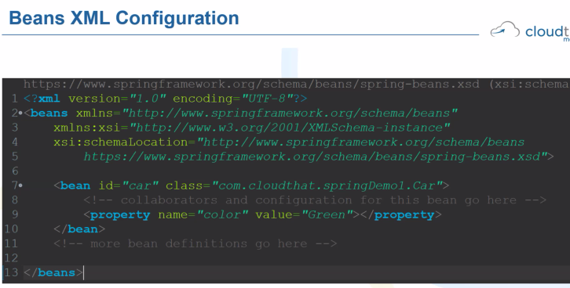

Lab : create a new maven project type quick in archytypr and create in pom file copy paste this code

<!-- <https://mvnrepository.com/artifact/org.springframework/spring-core> -->  
<dependency>  
<groupId>org.springframework</groupId>  
<artifactId>spring-core</artifactId>  
<version>6.1.14</version>  
</dependency>  
<!-- <https://mvnrepository.com/artifact/org.springframework/spring-context> -->  
<dependency>  
<groupId>org.springframework</groupId>  
<artifactId>spring-context</artifactId>  
<version>6.1.14</version>  
</dependency>

Inside src>main>java>app.java

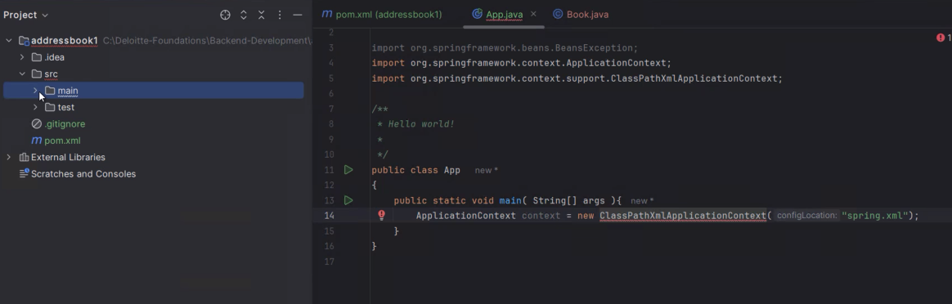

Create file book.java and copy paste yesterday’s librarymanagemenet system code

Create resources and insdide it spring.xml file

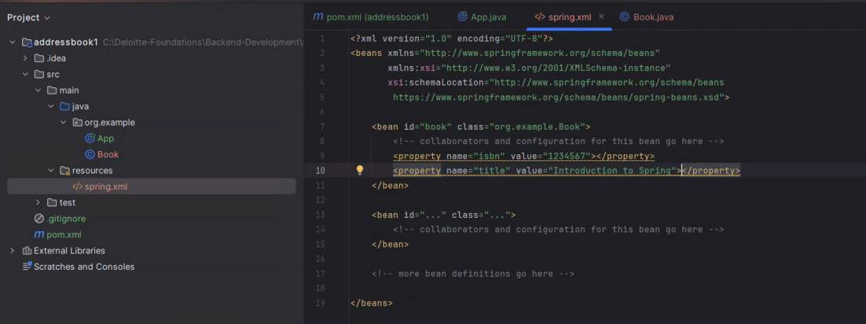

<https://github.com/Deloitte-vishwas/Deloitte-Foundations.git>

